# How to Create a Jar File in Java

<https://www.webucator.com/article/how-to-create-a-jar-file-in-java/>

看样子，jar文件（库）就是把javac编译的.class文件打包，类似把.obj文件打包为.lib的静态库文件。

A Java class can be stored in a jar (Java Archive) file. The classes in a jar file are stored in a compressed format, much like a zip file. A jar file is a portable container of classes. To understand how to create a jar file in Java, follow these seven steps.

1. Open your text editor and type in the following Java statements.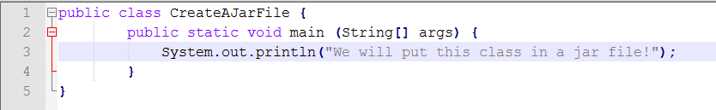This is a minimal program that serves the purpose of providing a class for your jar file.
2. Save your file as **CreateAJarFile.java**.
3. Open a command prompt and navigate to the directory containing your Java program. Then type in the command to compile the source and hit Enter.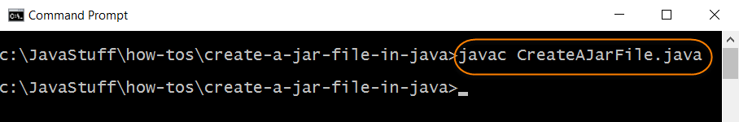
4. Test your program prior to placing it in a jar file. Type in the command to run the Java runtime launcher and then hit Enter.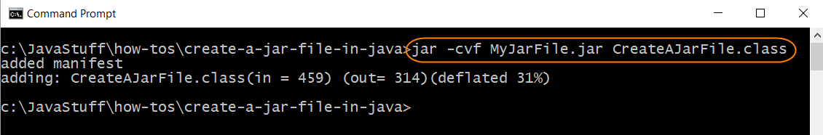
5. Now you will create a jar file containing your program. In your command prompt, make sure you're in the same directory as the previous step. Type in the following command and hit Enter.
6. The benefit of storing your class file in a jar file is that you can execute your class from any location on the file system. To illustrate this important point, navigate to the directory above the one where the class file is stored.
7. Execute the Java runtime launcher with the cp (classpath) option. Notice that the path specified on the classpath option references the directory that contains the jar file.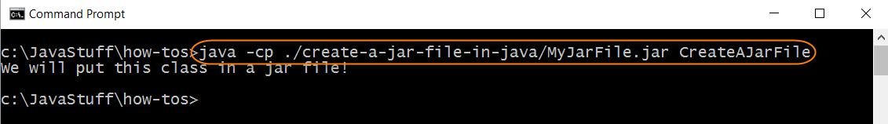You have successfully executed the class file stored in the jar file.